**EXPERIMENT NO:- 2**

**AIM:-**

To familiarize with selecting data from single table.

**PROCEDURE:**

1. List all data from table deposite

SELECT *FROM DEPOSITE;

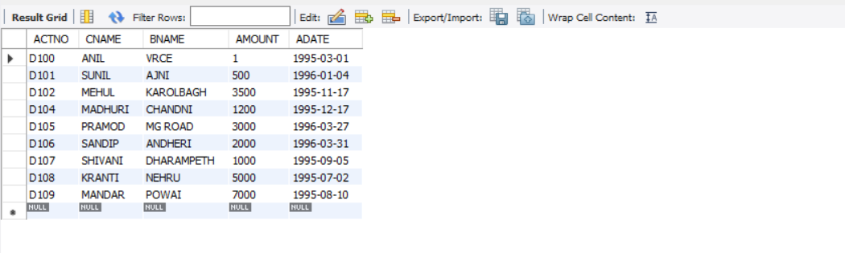

1. List all data from borrow

SELECT * FROM BORROW;

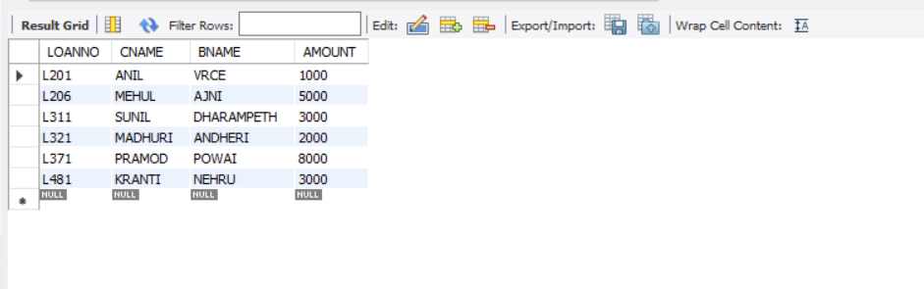

1. List all data from customer

SELECT * FROM CUSTOMER;

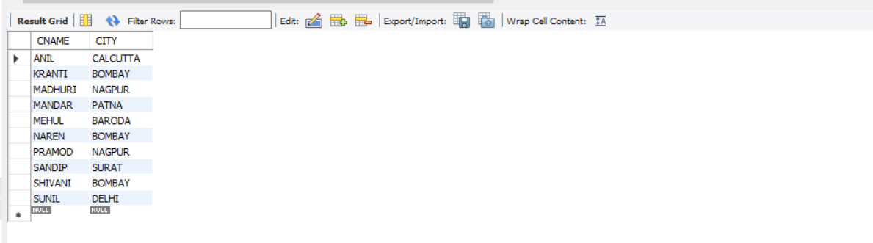

1. List all data from branch

SELECT * FROM BRANCH;

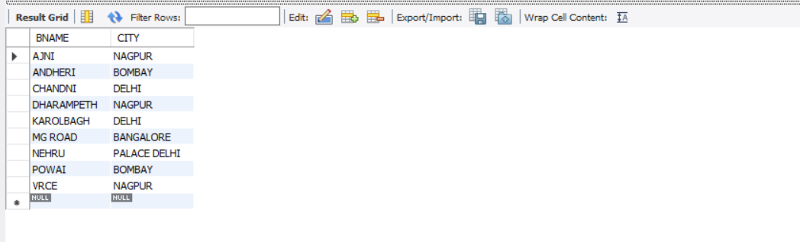

1. Give account no and amount of deposite

SELECT ACTNO, AMOUNT FROM DEPOSITE;

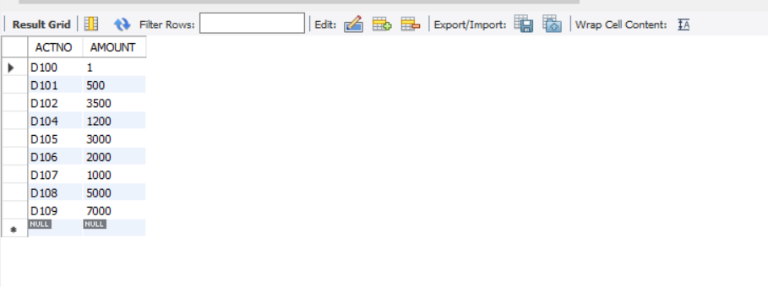

1. Give customer name and account no of depositors

SELECT CNAME,AMOUNT FROM DEPOSITE;

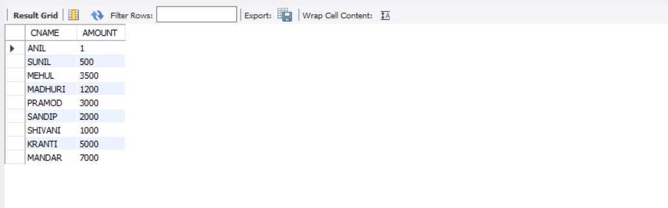

1. Give name of customers

SELECT CNAME FROM CUSTOMER;

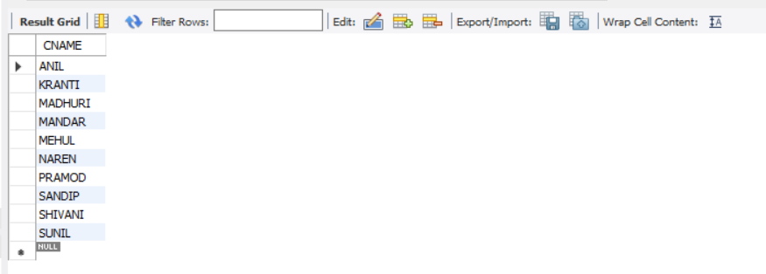

1. Give name of branches

SELECT BNAME FROM BRANCH;

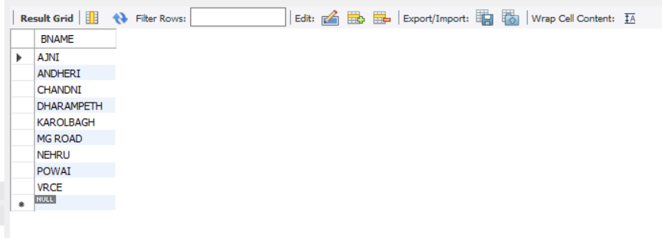

1. Give name of borrows

SELECT CNAME FROM BORROW;

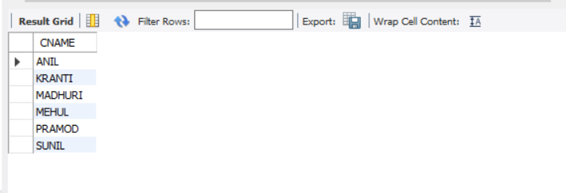

1. Give names of customer living in city Nagpur

SELECT CNAME FROM CUSTOMER WHERE CITY="NAGPUR";

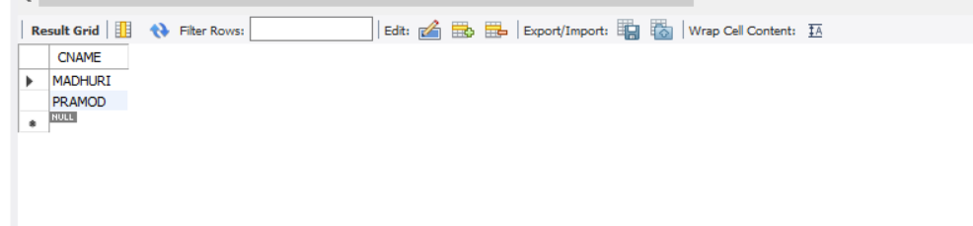

1. Give names of depositors having amount greater than 4000

SELECT CNAME FROM DEPOSITE WHERE AMOUNT>4000;

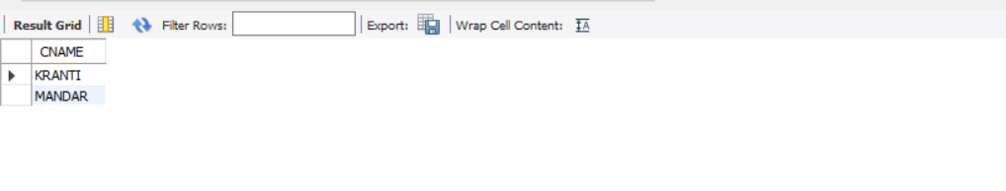

1. Give account date of Anil

SELECT ADATE FROM DEPOSITE WHERE CNAME="ANIL";

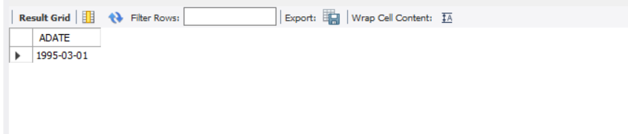

1. Give name of all branches located in Bombay

SELECT BNAME FROM BRANCH WHERE CITY="BOMBAY";

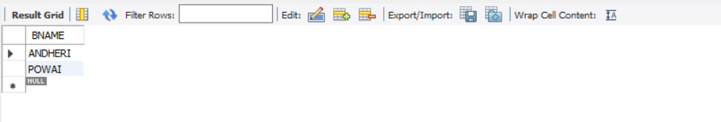

1. Give name of borrower having loan number l206

SELECT CNAME FROM BORROW WHERE LOANNO="L206";

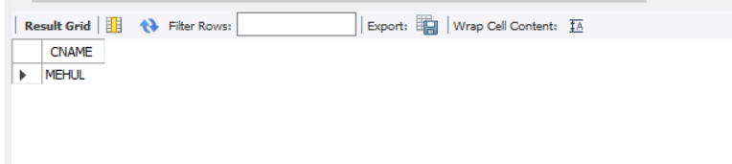

1. Give names of depositors having account at VRCE

SELECT CNAME FROM DEPOSITE WHERE BNAME="VRCE";

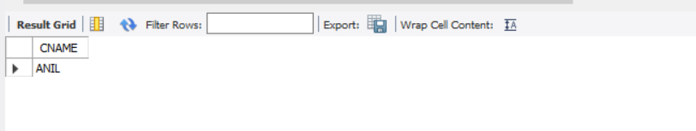

1. Give names of all branched located in city Delhi

SELECT BNAME FROM BRANCH WHERE CITY="DELHI";

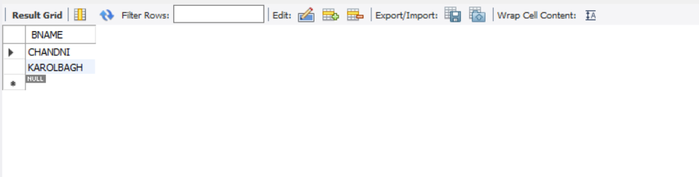

1. Give name of the customers who opened account date ‘5-9-95’

SELECT CNAME FROM DEPOSITE WHERE ADATE="1995-09-05";

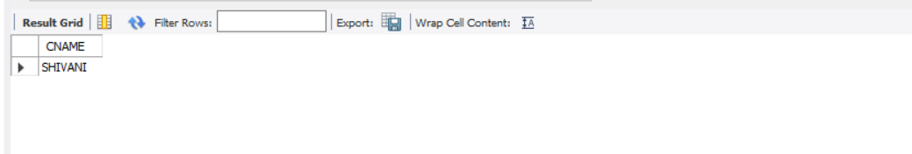

18.Give account no and deposit amount of customers having account opened between dates

‘1-03-95’ and ‘17-12-95’

SELECT ACTNO,AMOUNT FROM DEPOSITE WHERE ADATE BETWEEN '1995-03-01' and '1995-12-17';

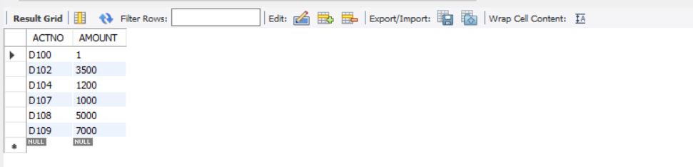

19.Give name of the city where branch KAROLBAGH is located

SELECT CITY FROM BRANCH WHERE BNAME="KAROLBAGH";

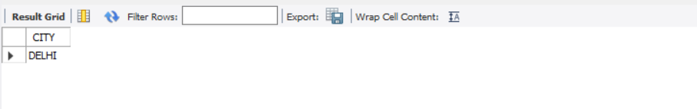

20.Give details of customer ANIL

SELECT * FROM DEPOSITE WHERE CNAME="ANIL";

